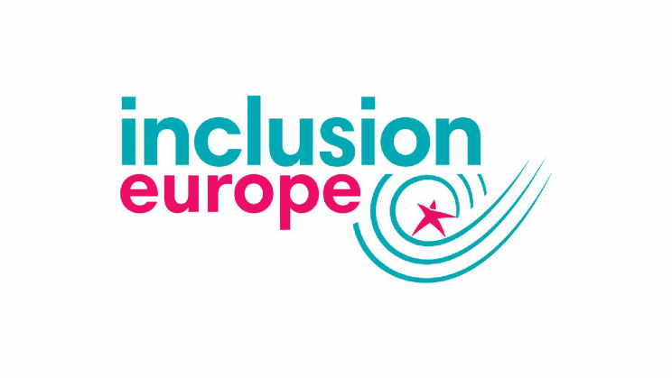
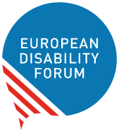

PRESS CONFERENCE
War on Ukraine: What Situation for Persons with Disabilities?
Thursday 10th March 2022, 11h-12h CET
ONLINE: REGISTER HERE

Interpretation (tbc)
- English – Ukrainian
- International Sign Language Interpretation
- English Captioning
Context
There are 2.7 million people with disabilities in Ukraine, according to the European Disability Forum, while Inclusion Europe estimates there are around 261.000 people with intellectual disabilities.
The War on Ukraine by the Russian Federation is a major threat to persons with disabilities with many of them being “left behind” as refugees flee the conflict.
This Press Conference will help inform journalists and interested stakeholders on the situation of persons with disabilities in Ukraine and what can be done to support them.
Programme
- Valery Sushkevych, President, National Assembly of Persons with Disabilities Ukraine (tbc)
- Raisa Kravchenko, VGO Coalition in Ukraine (tbc)
- Yannis Vardakastanis, Chair, International Disability Alliance
- Milan Šveřepa, Director, Inclusion Europe
- Maya Doneva, Secretary General, European Association of Service providers for Persons with Disabilities (EASPD)
Followed by a Q&A with Journalists.

For more information, please contact:
- Rachel Vaughan, Head of Operations, EASPD: rachel.vaughan(at)easpd.eu

